Introduction toTaxation
Introduction to Taxation
Meaning of tax
A tax may be defined as a "pecuniary burden laid upon individuals or property owners to support the Government, a payment exacted by legislative authority”. A tax "is not a voluntary payment or donation, but an enforced contribution, exacted pursuant to legislative authority". In simple words, tax is nothing but money that people have to pay to the Government, which is used to provide public services.
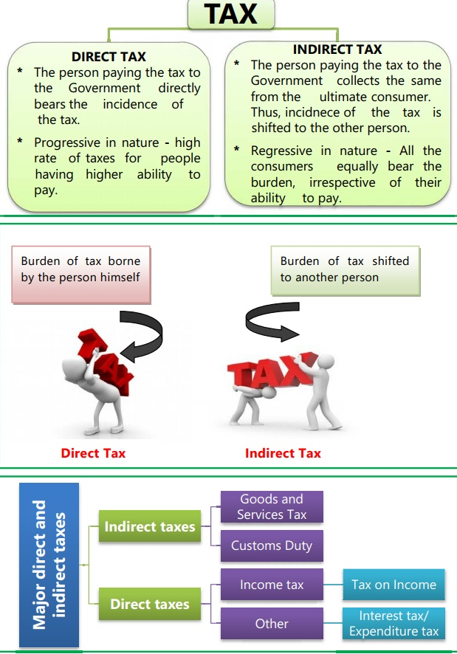
Kinds of taxes
1. Direct Tax
2. Indirect Tax.

Diagram 1.1

Introduction toTaxation

Direct Tax:
If a tax levied on the income or wealth of a person and is paid by that person (or his office) directly to the Government, it is called direct tax e.g. Income-Tax, Wealth Tax, Capital Gains Tax, Securities Transaction Tax, Fringe Benefits Tax (from 2005), Banking Cash Transaction Tax (for Rs.50,000 and above from 2005), etc. In India all direct taxes are levied and administered by Central Board of Direct Taxes.

Indirect Tax
An indirect tax is one in which the burden can be shifted to others. The tax payer is not the tax bearer. The impact and incidence of indirect taxes are on different persons. An indirect tax is levied on and collected from a person who manages to pass it on to some other person or persons on whom the real burden of tax falls. For e.g. commodity taxes or sales tax, excise duty, custom duties,GST etc. are indirect taxes.
The indirect taxes are the levies made by Central and State government on the expenditure, consumption, services, rights and privileges yet not on the property or income. This includes duties of customs paid on imports, as well as excise duty paid on production and value added tax on certain stages of production and distribution of products etc.
All these comprise to make indirect taxes since they are not directly applicable on the consumer’s income. Considering that indirect taxes are less as compared to income tax due to invisibility on pay slip, various state agencies tend to raise these taxes so as to generate higher revenue. Indirect tax is often also known as the consumption tax, since they are a regressive measure in application, and not rooted in paying ability.

Introduction toTaxation
Definition of Indirect Tax
According to Dalton,"In the case of a direct tax, the tax payer who pays a direct tax is also the tax bearer”. In the case of indirect taxes, the taxpayer and the tax bearer are different persons.

Features of Indirect Taxes
The features of indirect taxes that’ll help you understand them better:
- Indirect taxes are not levied on your annual income/profit but on goods and services you purchase
- While sellers of goods and services must pay indirect tax to the government, the burden is shifted to the customer. Thus, the tax is charged at the point of sale
- Indirect taxes tend to be regressive as the burden of taxation is a flat rate. However, the introduction of GST has helped change this in India
- Evading indirect taxes is impossible as they are included in the prices of various goods and services
- People with incomes crossing a certain threshold must pay direct taxes. However, indirect taxes have broader social coverage since they apply to all goods and services people purchase
- A high indirect tax means a higher price for the commodity or service. This generally incentivizes spending in consumers, motivating them to save and invest

Introduction toTaxation
Difference between Direct tax and Indirect tax

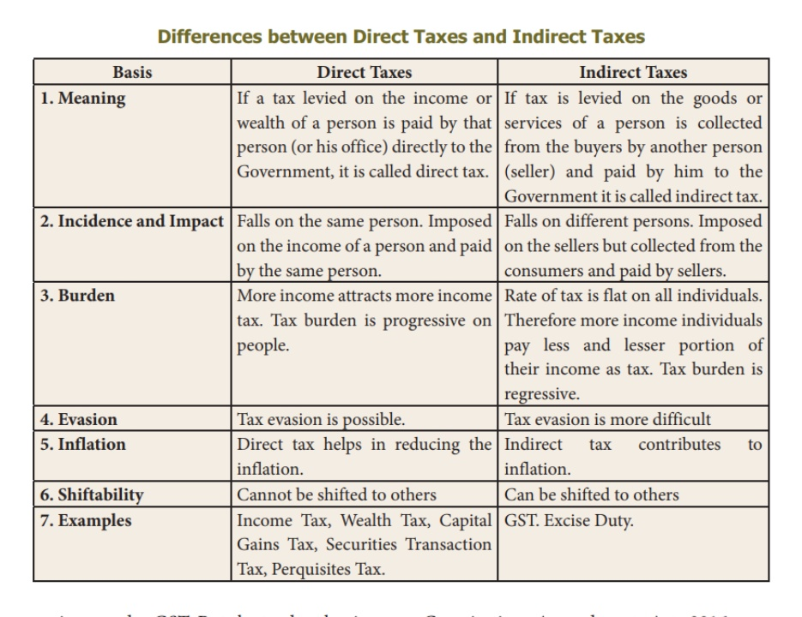
Introduction toTaxation
Types of Indirect Taxes:
Service Tax
Every paid service comes with a service tax. For instance, when you avail of various services like booking a hotel or cab services, you are liable to pay an indirect service tax on the value of the service.
Excise Duty
Also known as the Central Value Added Tax, Excise Duty applies to all goods produced within the country's borders. For instance, if your company manufactures laptops in India, you will have to pay excise duty. This tax amount is later recovered from customers
Customs Duty
This type of indirect tax is charged on goods imported into India. For instance, a customs duty will apply to gold or diamond jewellery you bring back from a foreign trip.
Value-Added Tax
VAT is the indirect tax levied on the value added at every stage of the supply chain. For instance, you purchase gold jewellery for ₹3 Lakhs. If the applicable VAT rate is 1%, the VAT payable on the amount will be ₹3,000.
Stamp Duty
Stamp Duty serves as legal proof of ownership. It is levied on the sale of immovable property in India. For instance, if you buy a property, the stamp duty must be paid in full per the state government’s taxation rates.
Entertainment Tax
Transactions related to entertainment are subject to entertainment taxes. For instance, if you purchase movie or concert tickets online, you will need to pay the entertainment tax according to the state government's applicable rates.
GST
In 2017, GST, or the Goods and Service Tax, was introduced in India to subsume 17 different indirect taxes at the central and state levels. Eliminating the cascading effect of indirect taxes, GST has absorbed the following major types of indirect taxes:
Introduction toTaxation
At the Central level:
- Sales tax
- Entertainment tax
- Purchase tax
- Octroi and Entry tax
- Luxury Tax
At the State level:
- Service tax
- Excise duty
- Additional custom duty
- Countervailing duty
So, for instance, you’re dining at a restaurant, and the total bill comes to Rs.3,000, and the GST applied is 5%. Then, the total payable will be Rs.3,150, where Rs.150 is the indirect tax.

Introduction toTaxation

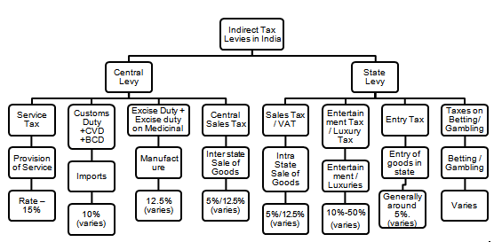
Introduction toTaxation
Taxation in India before GST
Liability of Tax
Here the seller or service provider makes payment on indirect taxes which are transferred to final consumer.
Investment and Saving
Most indirect taxes are largely growth-oriented since they de-motivate the consumer and encourage savings.
Social Coverage:
The indirect tax has a much larger coverage since their charge falls upon each individual buying products or services.
An important source of revenue:
Indirect taxes are a major source of tax revenues for Governments worldwide and continue to grow as more countries move to consumption oriented tax regimes. In India, indirect taxes contribute more than 50% of the total tax revenues of Central and State Governments.
Tax on commodities and services:
It is levied on commodities at the time of manufacture or purchase or sale or import/export thereof. Hence, it is also known as commodity taxation. It is also levied on provision of services.
Shifting of burden:
There is a clear shifting of tax burden in respect of indirect taxes. For example, GST paid by the supplier of the goods is recovered from the buyer by including the tax in the cost of the commodity.
No perception of direct pinch:
Since, value of indirect taxes is generally inbuilt in the price of the commodity, most of the time the tax payer pays the same without actually knowing that he is paying tax to the Government. Thus, tax payer does not perceive a direct pinch while paying indirect taxes.
Introduction toTaxation
Inflationary:
Tax imposed on commodities and services causes an all-round price spiral.In other words, indirect taxation directly affects the prices of commodities and services and leads to inflationary trend.
Wider tax base:
Unlike direct taxes, the indirect taxes have a wide tax base. Majority of the products or services are subject to indirect taxes with low thresholds.
Promotes social welfare:
High taxes are imposed on the consumption of harmful products (also known as ‘sin goods’) such as alcoholic products, tobacco products etc. This not only checks their consumption but also enables the State to collect substantial revenue.
Regressive in nature: Generally, the indirect taxes are regressive in nature. The rich and the poor have to pay the same rate of indirect taxes on certain commodities of mass consumption. This may further increase the income disparities between the rich and the poor.
Hicks classifies direct & indirect taxes on the basis of administrative arrangements. In case of direct tax-there is a direct relationship between the taxpayer and the revenue authorities. A tax collecting agency directly collects the tax from the taxpayers, whereas in case of indirect taxes there is no direct relationship between the taxpayers and the revenue authorities. They are collected through traders and manufacturers.
Over the years the share of indirect tax has declined in India due to reduction in the rates of indirect taxes.

Advantages / Merits of Indirect Taxes
The merits of indirect taxes are briefly explained as follows :-
1. Convenient
Indirect taxes are imposed on production, sale and movements of goods and services. These are imposed on manufacturers, sellers and traders, but their burden may be shifted to consumers of goods and services who are the final taxpayers. Such taxes, in the form of higher prices, are paid only on purchase of a commodity or the
Introduction toTaxation
enjoyment of a service. So taxpayers do not feel the burden of these taxes. Besides, money burden of indirect taxes is not completely felt since the tax amount is actually hidden in the price of the commodity bought. They are also convenient because generally they are paid in small amounts and at intervals and are not in one lump sum. They are convenient from the point of view of the government also, since the tax amount is collected generally as a lump sum from manufacturers or traders.
2. Difficult to evade
Indirect taxes have in built safeguards against tax evasion. The indirect taxes are paid by customers, and the sellers have to collect it and remit it to the Government. In the case of many products, the selling price is inclusive of indirect taxes. Therefore, the customer has no option to evade the indirect taxes.
3. Wide Coverage
Unlike direct taxes, the indirect taxes have a wide coverage. Majority of the products or services are subject to indirect taxes. The consumers or users of such products and services have to pay them.
4. Elastic
Some of the indirect taxes are elastic in nature. When government feels it necessary to increase its revenues, it increases these taxes. In times of prosperity indirect taxes produce huge revenues to the government.
5. Universality
Indirect taxes are paid by all classes of people and so they are broad based. Poor people may be out of the net of the income tax, but they pay indirect taxes while buying goods.
6. Influence on Pattern of Production
By imposing taxes on certain commodities or sectors, the government can achieve better allocation of resources. For e.g. By Imposing taxes on luxury goods and making them more expensive, government can divert resources from these sectors to sector producing necessary goods.
7. May not affect motivation to work and save
The indirect taxes may not affect the motivation to work and to save. Since, most of the indirect taxes are not progressive in nature, individuals may not mind to pay them. In other words, indirect taxes are generally
Introduction toTaxation
regressive in nature. Therefore, individuals would not be demotivated to work and to save, which may increase investment.
8. Social Welfare
The indirect taxes promote social welfare. The amount collected by way of taxes is utilized by the government for social welfare activities, including education, health and family welfare. Secondly, very high taxes are imposed on the consumption of harmful products such as alcoholic products, tobacco products, and such other products. So it is not only to check their consumption but also enables the state to collect substantial revenue in this manner.
9. Flexibility and Buoyancy
The indirect taxes are more flexible and buoyant. Flexibility is the ability of the tax system to generate proportionately higher tax revenue with a change in tax base, and buoyancy is a wider concept, as it involves the ability of the tax system to generate proportionately higher tax revenue with a change in tax base, as well as tax rates.

Disadvantages / Demerits of Indirect Taxes
Although indirect taxes have become quite popular in both developed & Under developed countries alike, they suffer from various demerits, of which the following are important.
1. High Cost of Collection
Indirect tax fails to satisfy the principle of economy. The government has to set up elaborate machinery to administer indirect taxes. Therefore, cost of tax collection per unit of revenue raised is generally higher in the case of most of the indirect taxes.
2. Increase income inequalities
Generally, the indirect taxes are regressive in nature. The rich and the poor have to pay the same rate of indirect taxes on certain commodities of mass consumption. This may further increase income disparities among the rich and the poor.
Introduction toTaxation
3. Affects Consumption
Indirect taxes affects consumption of certain products. For instance, a high rate of duty on certain products such as consumer durables may restrict the use of such products. Consumers belonging to the middle class group may delay their purchases, or they may not buy at all. The reduction in consumption affects the investment and production activities, which in turn hampers economic growth.
4. Lack of Social Consciousness
Indirect taxes do not create any social consciousness as the taxpayers do not feel theburden of the taxes they pay.
5. Uncertainty
Indirect taxes are often rather uncertain. Taxes on commodities with elastic demand are particularly uncertain, since quantity demanded will greatly affect as prices go up due to the imposition of tax. In fact a higher rate of tax on a particular commodity may not bring in more revenue.

6. Inflationary
The indirect taxes are inflationary in nature. The tax charged on goods and services increase their prices. Therefore, to reduce inflationary pressure, the government may reduce the tax rates, especially, on essential items.
7. Possibility of tax evasion
There is a possibility of evasion of indirect taxes as some customers may not pay indirect taxes with the support of sellers. For instance, individuals may purchase items without a bill, and therefore, may not pay Sales tax or VAT (Value Added Tax), or may obtain the services without a bill, and therefore, may evade the service tax.
Taxation in India.(Constitutional provisions)
India has a three-tier federal structure, comprising the Union Government, the State Governments and the Local Government. The power to levy taxes and duties is distributed among the three tiers of Governments, in accordance with the provisions of the Indian Constitution.
Introduction toTaxation
The Constitution of India is the supreme law of India. It consists of a Preamble, 25 parts containing 448 Articles and 12 Schedules.
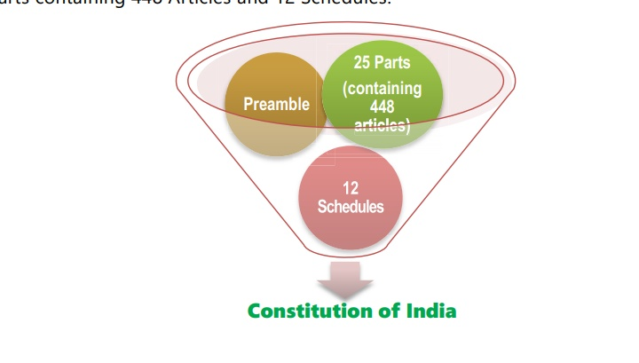

Diagram 1.3
Thus, a study of the basic provisions of the Constitution is essential for understanding the genesis of the various taxes being imposed in India. The significant provisions of the Constitution relating to taxation are:
I. Article 265: Article 265 of the Constitution of India prohibits arbitrary collection of tax. It states that “no tax shall be levied or collected except by authority of law”. The term “authority of law” means that tax proposed to be levied must be within the legislative competence of the Legislature imposing the tax.
II. Article 245: Part XI of the Constitution deals with relationship between the Union and States. The power for enacting the laws is conferred on the Parliament and on the Legislature of a State by Article 245 of the Constitution. The said Article provides as under
- Subject to the provisions of this Constitution, Parliament may make laws for the whole or any part of the territory of India, and the legislature of a State may make laws for the whole or any part of the State.
- No law made by the Parliament shall be deemed to be invalid on the ground that it would have extra-territorial operation.
III. Article 246: It gives the respective authority to Union and State Governments for levying tax. Whereas Parliament may make laws for the whole of India or any part of the territory of India, the State Legislature may make laws for whole or part of the State
Introduction toTaxation
IV. Seventh Schedule to Article 246: It contains three lists which enumerate the matters under which the Union and the State Governments have the authority to make laws.
List I-----UNION LIST It contains the matters in respect of which the Parliament(Central Government)has the exclusive right to make laws.
LIST – II -----STATE LIST It contains the matters in respect of which the State Government has the exclusive right to make laws.
List-III----- CONCURRENT LIST It contains the matters in respect of which both the Central l& State Governments have power to make law.
Entries 82 to 91 of List I enumerate the subjects where the Central Government has power to levy taxes. Entries 45 to 63 of List II enumerate the subjects where the State Governments have the power to levy taxes. Parliament has a further power to make any law for any part of India not comprised in a State even if such matter is included in the State List.

Income tax is levied by virtue of Entry 82 - Taxes on income other than agricultural income and customs duty vide Entry 83 - Duties of customs including export duties of the Union List. Power to levy Goods and Services Tax (GST) has been conferred by Article 246A of the Constitution which was introduced by the Constitution (101st Amendment) Act, 2016. Before discussing the significant provisions of the Constitution (101st Amendment) Act, 2016, let us first understand why there arose a need for such constitutional amendment.
Need for constitutional amendment
The Constitutional provisions hitherto had delineated separate powers for the Centre and the States to impose various taxes. Whereas the Centre levied excise duty on all goods produced or manufactured in India, the States levied Value Added Tax once the goods entered the stream of trade upon completion of manufacture. In the case of inter-State sales, the Centre had the power to levy a tax (the Central Sales Tax), but the tax was collected and retained entirely by the States. Services were exclusively taxed by the Centre together with applicable cesses, if any. Besides, there were State specific levies like entry tax, Octroi, luxury tax, entertainment tax, lottery and betting tax, local taxes levied by Panchayats etc. With respect to goods imported from outside the country into India, Centre levied basic customs duty and additional duties of customs together with applicable cesses, if any. Introduction of the GST required amendment in the Constitution so as to enable
Introduction toTaxation
integration of the central excise duty including additional duties of customs, State VAT and certain State specific taxes and service tax levied by the Centre into a comprehensive Goods and Services Tax and to empower both Centre and the States to levy and collect it. Consequently, Constitution (101st Amendment Act), 2016 (hereinafter referred to as Constitution Amendment Act) was passed. It has 20 sections. Newly inserted Article 279A empowering President to constitute GST Council was notified on 12.09.2016. Remaining provisions were notified with effect from 16.09.2016.
CAA also provides for compensation to States for loss of revenue on account of introduction of goods and services tax. Parliament shall, by law, on the recommendation of the Goods and Services Tax Council, provide for compensation to the States for loss of revenue arising on account of implementation of the goods and services tax for a period of five years.
Significant provisions of Constitution (101st Amendment) Act, 2016

Key changes in brief
- Concurrent powers on Parliament and State Legislatures to make laws governing taxes on goods and services.
- Levy of integrated goods and services tax on inter-State transactions of goods and services to be levied and collected by the Central Government and apportioned between the Union and the States in the manner provided by Parliament by Law as per the recommendation of the GST Council
- Principles for determining the place of supply and when a supply takes place in the course of inter-State trade or commerce shall be formulated by the Parliament, by law.
- GST will be levied on all supply of goods and services except alcoholic liquor for human consumption.
- On the following products GST shall not be levied, till a date to be notified on the recommendations of the GST Council:

Introduction toTaxation
Petroleum Crude
High Speed Diesel
Motor Spirit (commonly known as Petrol
Natural Gas
Aviation Turbine Fuel
The Union Government shall retain the power to levy duties of excise on the aforesaid products besides tobacco and tobacco products manufactured or produced in India.
Article 279A of the Constitution empowers the President to constitute a joint forum of the Centre and States namely, Goods & Services Tax Council(GST Council).
The provisions relating to GST Council came into force on 12th September, 2016. President constituted the GST Council on 15th September, 2016.

The Union Finance Minister is the Chairman of this Council and Ministers in charge of Finance/Taxation or any other Minister nominated by each of the States & UTs with Legislatures are its members. Besides, the Union Minister of State in charge of Revenue or Finance is also its member. The function of the Council is to make recommendations to the Union and the States on important issues like tax rates, exemptions, threshold limits, dispute resolution etc.
The concept of ‘declared goods of special importance’ under the Constitution is done away with. Presently, certain restrictions are placed on the powers of States in regard to tax on such goods.
Transitional provisions to take care of any inconsistency with respect to any law relating to tax on goods or services or both, in force in any State. Such tax to continue to be in force until amended or repealed or until expiration of one year from commencement of GST, whichever is earlier.
Key changes in detail
Significant amendments made by Constitution Amendment Act are discussed below in detail:
V. Article 246A: Power to make laws with respect to Goods and Services Tax:
Newly inserted Article 246A
(1) Notwithstanding anything contained in Articles 246 and 254, Parliament, and, subject to clause (2), the
Introduction toTaxation
Legislature of every State, have power to make laws with respect to goods and services tax imposed by the Union or by such State.
(2) Parliament has exclusive power to make laws with respect togoods and services tax where the supply of goods, or of services, or both takes place in the course of inter-State trade or commerce.
Explanation—The provisions of this article, shall, in respect of goods and services tax referred to in clause (5) of article 279A, take effect from the date recommended by the Goods and Services Tax Council. This article grants power to Centre and State Governments to make laws with respect to GST imposed by Centre or such State. Centre has the exclusive power to make laws with respect to GST in case of inter-State supply of goods and/or services .However, in respect to

the following goods, the aforesaid provisions shall apply from the date recommended by the GST Council:
- This article grants power to Centre and State Governments to make laws with respect to GST imposed by Centre or such State.
- Centre has the exclusive power to make laws with respect to GST in case of inter-State supply of goods and/or services.
- However, in respect to the following goods, the aforesaid provisions shall apply from the date recommended by the GST Council:
*petroleum crude
*high speed diesel
*motor spirit (commonly known as petrol)
*Natural gas
*aviation turbine fuel
- The provisions of Article 246A are notwithstanding anything contained in Articles 246 and 254. Article 254 deals with the supremacy of the laws made by Parliament.
VI. Article 248 amended Residuary powers of legislation amended

Introduction toTaxation
- Article 248 grants the residuary powers to Parliament to make laws with respect to any matter not enumerated in the Concurrent List or State List. Such power shall include the power of making any law imposing a tax not mentioned in either of those Lists.
- This article has been amended. Now, this power has been subjected to Article 246A, namely the power to make laws with respect to goods and service tax to be imposed by the Centre and States.
VII. Power of Parliament to legislate with respect to a matter in the State List, in the national interest/in case of emergency, extended to GST provided under Article 246A
- Article 249 grants the Parliament the power to make laws with respect to a matter in the State list in national interest in a case where the Council of States has declared by resolution supported by not less than two-thirds of the members present and voting on any matter enumerated in the State List.
- Similarly, Article 250 grants the Parliament the power to make laws with respect to any of the matters enumerated in the State List if a proclamation of Emergency is in operation.
- Articles 249 and 250 have been amended to grant power to Parliament to make laws with respect to the Goods and Services Tax provided under Article 246A also alongwith the matters in the State list, in the national interest/in case of emergency.
VIII.Article 268: Duties levied by the Centre but collected and appropriated by the States
- Article 268 pertains to the duties levied by the Centre but collected and appropriated by the States. It stipulates that such stamp duties and such duties of excise on medicinal and toilet preparations as are mentioned in the Union List shall be levied by the Government of India but shall be collected in the case where such duties are leviable within any Union territory, by the Government of India, and in other cases, by the States within which such duties are respectively leviable.
- The CAA omits “and such duties of excise on medicinal and toilet preparations” from Article 268.
- Duties of excise on medicinal and toilet preparations have been subsumed into the goods and service tax to be levied by the Centre and States.
IX. Article 268A: Article 268A empowering Union to levy service tax omitted
Introduction toTaxation
- Service tax was levied in 1994 under the residual Entry 97 of the Union list. Article 268A was inserted by the Constitution (88th)
Amendment Act, 2003 to usher in service tax
under a separate entry 92C in the Union List. However, it was not notified ever since. This article has been omitted by the CAA.
X. Article 269A: Levy and collection of GST on inter-State supply
Newly inserted article 269A. Levy and collection of goods and services tax in course of inter-State trade or commerce
(1) Goods and services tax on supplies in the course of inter-State trade or commerce shall be levied and collected by the Government of India and such tax shall be apportioned between the Union and the States in the manner as may be provided by Parliament by law on the recommendations of the Goods and Services Tax Council.
Explanation — For the purposes of this clause, supply of goods, or of services, or both in the course of import into the territory of India shall be deemed to be supply of goods, or of services, or both in the course of inter-State trade or commerce.
(2) The amount apportioned to a State under clause (1) shall not form part of the Consolidated Fund of India.
(3) Where an amount collected as tax levied under clause (1) has been used for payment of the tax levied by a State under article 246A, such amount shall not form part of the Consolidated Fund of India.
(4) Where an amount collected as tax levied by a State under article 246A has been used for payment of the tax levied under clause (1), such amount shall not form part of the Consolidated Fund of the State.
(5) Parliament may, by law, formulate the principles for determining the place of supply, and when a supply of goods, or of services, or both takes place in the course of inter-State trade or commerce.
- Article 269A stipulates that GST on supplies in the course of inter-State
trade or commerce shall be levied and collected by the Government of India and such tax shall be apportioned between the Union and the States in the manner as may be provided by Parliament by law on the recommendations of the Goods and Services Tax Council.
- Further, import of goods or services or both into India will also be deemed to be supply of goods and/ or services in the course of InterState trade or Commerce. This will give power to Central Government to levy IGST on the import transactions which were earlier subject to Countervailing duties under the Customs Tariff Act, 1975.
Introduction toTaxation
- Where an amount collected as IGST has been used for payment of SGSTor vice versa, such amount shall not form part of the Consolidated Fund of India. This is to facilitate transfer of funds between the Centre and the States.
- Parliament is empowered to formulate the principles regarding place of supply and when supply of goods, or of services, or both occurs in interState trade or commerce.

XI. Article 270: Distribution of the goods and services tax (GST) between the Centre and the States
- Article 270 is amended to provide for distribution of the goods and services tax between the Centre and the States, by order of the President after considering recommendations of the Finance Commission.
- This applies for those tax amounts apportioned or payable to the Central Government for taxes levied by it under articles 246A(1) and (2) and Clause (1) of 269A.

XII.Article 271 amended
- Article 271 empowers Parliament to increase any of the duties, or taxes referred to in articles 269 or 270. It further provides that such surcharge is not shareable and remains with the Centre. Now this article is amended to exclude GST from its purview.
Xlll. Definitions of ‘Goods and Services Tax’, ‘Services’ and ‘State’ incorporated under Article 366
The terms Goods and Services Tax, services and State have been defined under respective clauses of Article 366 as follows:
- Goods and services tax means any tax on supply of goods, or services or both except taxes on the supply of the alcoholic liquor for human consumption. Consequently, GST can be levied on supply of all goods and services except alcoholic liquor for human consumption.
- Services means anything other than goods.
- State, with reference to articles 246A, 268, 269, 269A and article 279A, includes a Union territory with Legislature.

Introduction toTaxation
- Definition of “goods”: The term goods has already been defined under clause (12) of Article 366 in an inclusive manner to provide that “goods includes all materials, commodities, and articles”.
Xlv. Article 286: Article 286 imposing restrictions as to imposition of tax on the sale or purchase of goods amended
- Article 286 which restrains the States from framing laws for imposition of any tax on the sale or purchase of goods where such sale or purchase takes place outside the State or in course of the import of the goods into, or export of the goods out of, the territory of India.
- This article has been amended to incorporate the changes arising out of GST by substituting the words “sale or purchase” with “supply” and words “goods” with “goods or services or both”.
- Consequently, States have no right to impose GST on inter-State supply of goods or services or both. It will be levied by Union Government under Article 269A as mentioned earlier.
- Further, clause (3) of Article 286 which stipulates that any law of a State shall, in so far as it imposes, or authorises the imposition, of a tax on the sale or purchase of goods declared by Parliament by law to be of special importance in inter-State trade or commerce, be subjected to such restrictions and conditions in regard to the system of levy, rates and other incidents of the tax, as Parliament may, by law, specify, has been omitted.
Xv. GST Council: Article 279A
- Article 279A of the Constitution empowers the President to constitute a joint forum of the Centre and States namely, Goods & Services Tax Council (GST Council).
- The provisions relating to GST Council came into force on 12th September, 2016. President constituted the GST Council on 15th September, 2016.
- The GST Council shall consist of the following members, namely:—
(a) the Union Finance Minister is the Chairperson;

Introduction toTaxation
(b) the Union Minister of State in charge of Revenue or Finance is the Member;
c) the Minister in charge of Finance or Taxation or any other Minister nominated by each State Government are the Members.
- The Members of the GST Council referred to clause (c) above shall, as soon as may be, choose one amongst themselves to be the ViceChairperson of the Council for such period as they may decide.
- The GST Council shall make recommendations to the Union and the States on—
(a) the taxes, cesses and surcharges levied by the Union, the States and the local bodies which may be subsumed in the goods and services tax;
(b) the goods and services that may be subjected to, or exempted from the goods and services tax;
(c) model Goods and Services Tax Laws, principles of levy, apportionment of Goods and Services Tax levied on supplies in the course of inter-State trade or commerce under article 269A and the principles that govern the place of supply;
(d) the threshold limit of turnover below which goods and services may be exempted from goods and services tax;
(e) the rates including floor rates with bands of goods and services tax;
(f) any special rate or rates for a specified period, to raise additional resources during any natural calamity or disaster;
(g) special provision with respect to the States of Arunachal Pradesh, Assam, Jammu and Kashmir, Manipur, Meghalaya, Mizoram, Nagaland, Sikkim, Tripura, Himachal Pradesh and Uttarakhand [Such States are referred as Special Category States]; and
(h) any other matter relating to the goods and services tax, as the Council may decide.
- The GST Council shall recommend the date on which the goods and services tax be levied on petroleum crude, high speed diesel, motor spirit (commonly known as petrol), natural gas and aviation turbine fuel.
- While discharging the functions conferred by this article, the GST Council shall be guided by the need for a harmonised structure of goods and services tax and for the development of a harmonised national market for goods and services.
- One-half of the total number of Members of the GST Council shall constitute the quorum at its meetings.
- The GST Council shall determine the procedure in the performance of its functions.

Introduction toTaxation
- Every decision of the GST Council shall be taken at a meeting, by a majority of not less than three-fourths of the weighted votes of the members present and voting, in accordance with the following principles, namely:
(a) the vote of the Central Government shall have a weightage of one-third of the total votes cast, and
(b) the votes of all the State Governments taken together shall have a weightage of two-thirds of the total votes cast, in that meeting.
- No act or proceedings of the Goods and Services Tax Council shall be invalid merely by reason of—
(a) any vacancy in, or any defect in, the constitution of the Council; or
(b) any defect in the appointment of a person as a Member of the Council; or
(c) any procedural irregularity of the Council not affecting the merits of the case.
- The Goods and Services Tax Council shall establish a mechanism to adjudicate any dispute —
(a) between the Government of India and one or more States; or
(b) between the Government of India and any State or States on one side and one or more other States on the other side; or
(c) between two or more States, arising out of the recommendations of the Council or implementation thereof.

XVI. Article 368 amended
- Article 368 has been amended to include Article 279A also within its purview. Consequently, at least two-thirds of the majority in each House of the Parliament and ratification by at least half of the States is specifically required to make any amendment in Article 279A relating to GST Council.

Contribution to Government Revenues
Introduction
Revenues of India are shared by central government and state government as per the constitution law of India .
Revenue
Introduction toTaxation
Revenue from fiscal monopolies (liquor and gaming profits) are now considered taxes. They were previously classified under investment income.
The category "Privileges, licences and permits" was deleted. Items such as business licences, motor vehicle licences and all local government licences and permits are treated as taxes while most personal paid licences are classified as sales of goods and services.
Grants in lieu of taxes, which were treated as transfers are now classified under property and related taxes.
The category "Natural resource revenue" was deleted. Natural resource royalties are now considered investment income while mining and logging taxes are now allocated to the income taxes category.
The tax category "Health and social insurance levies" has been split into two new non-tax categories, namely: "Health insurance premiums" and "Contributions to social insurance plans."
Own source revenue
Income taxes
(a) Personal income tax - Encompasses general levies on income of individuals and unincorporated businesses as well as special levies on income, such as a surtax that governments charge from time to time. The proceeds from the income tax on capital gains of individuals and unincorporated businesses are included here. Some provinces, for example Ontario, levy health premiums based on the incomes of individualsand the revenues raised are not specifically designated to finance their hospitalization, medical care and drug insurance programs.

In these instances the revenues are classified as income taxes. Also, refundable personal income tax credits are in this category. Revenue and expenditures are both grossed up by the full amount of the refundable tax credit. A refundable tax credit could be considered as an expenditure program delivered via the tax system. Consequently such a credit reduces the tax liabilities and the portion of the credits remaining, after the tax liabilities are reduced to zero, is refunded to the tax payer. The Ontario sales tax credit represents a good example. Until 1992/1993, the credit was delivered through the budgetary expenditure appropriation called "Sales tax grants to pensioners." After 1992/1993 the Ontario government decided to switch to the income tax mechanism by incorporating the Ontario sales tax credit to deliver the assistance to pensioners.
Introduction toTaxation
(b) Corporation income tax - Includes most federal, provincial and territorial taxes on taxable profits of corporations. It also includes special taxes which are occasionally levied on profits of corporations. Corporate Income Tax (CIT) revenues are shown on a gross basis by including the full amount of the CIT refundable tax credits as revenue. An equivalent amount of the refundable tax credit is also shown as an expenditure.

(c) Mining and logging taxes - Accounts for specific taxes which are sometimes levied on profits of natural resource based industries. Also included are refundable tax credits that are grossed up as revenue and expenditures. These taxes were previously classified to natural resource revenue.

(d) Taxes on payments to non-residents - Includes the federal tax withheld at source on payments to non-residents (both individuals and corporations) of dividends, interest, rents, royalties, alimony, managerial fees and amounts arising from trusts and estates as well as withholdings on foreign insurance companies.

(e) Other income taxes - Includes income taxes which cannot be allocated to any of the other categories.

Consumption taxes
(a) General sales tax - The proceeds of the federal Goods and Services Tax (GST) and of provincial retail sales taxes are recorded in this category. In April 1996, the federal government reached an agreement with three provinces to harmonize their provincial retail sales taxes with the federal GST (Newfoundland and Labrador, New Brunswick and Nova Scotia). The federal remittances to these provinces for this Harmonized Sales Taxes (HST) are classified under the general sales tax. However, the one time compensation of the federal to the provinces for harmonization is included under general purpose transfers. Where amusement taxes and other specific consumption taxes are reported in the source documents with revenue from the general sales taxes, the proceeds from these specific taxes, e.g., the Ontario amusement tax, are excluded from this category and

Introduction toTaxation
reported under their appropriate group. Hotel and motel taxes, telecommunications and advertising taxes and the Quebec sales tax on insurance premiums are not part of the general sales tax.
(b) Alcoholic beverages taxes - Two sub-groups have been devised:

Liquor gallonage taxes - Encompasses a levy on volume of alcoholic beverages produced.
Other liquor taxes - Includes all forms of special levies, excise tax, excise duty or other, imposed on the production and sale of alcoholic beverages. When a general sales tax applies to alcoholic beverages, the related proceeds are classified under the "General sales tax" group. Similarly, customs duties on imported alcoholic beverages are classified under the "Custom duties" heading.
(c) Tobacco tax - Encompasses special levies such as excise tax, excise duty and provincial specific taxes on the production and sale of tobacco products. General sales taxes and customs duties applicable to tobacco products are included under their respective headings.
(d) Amusement tax - Includes tax receipts from admissions to theaters, cinemas, recreational, cultural or other entertainment activities. Taxes levied by provincial and territorial governments on pari-mutuel betting at horse race tracks and on casinos' gaming activities are also included here.

(e) Gasoline and motive fuel taxes - Includes the proceeds of specific taxes on gasoline, on aviation and diesel fuel and on propane or other substances when used as motive fuel.

(f) Customs duties - Applies only to the federal level and take into account the proceeds from levies on commodities imported into Canada such as manufactured goods and food,beverages and tobacco.

(g) Remitted liquor profits - Accounts for total remitted profits of government owned liquor boards. Because government owned liquor boards operate as fiscal monopolies their profits are treated as taxes on products (indirect taxes). They were previously classified as investment income.
Introduction toTaxation
(h) Remitted gaming profits - Accounts for total remitted profits of government owned lottery and other gaming corporations. Because government owned lottery and other gaming corporations operate as fiscal monopolies, their profits are considered as taxes on products (indirect taxes). Those amounts were previously classified as investment income.

(i) Other consumption taxes - Three sub-groups have been devised:

Air transportation tax- Accounts for the tax levied by the federal government on the price of air transportation purchased either in Canada or outside the country for the use of air transportation facilities in Canada. This tax was discontinued on November 1, 1998.

Taxes on meals and hotels - Includes the proceeds from special taxes on meals and hotel accommodations.
Miscellaneous consumption taxes - Accounts at the federal level for the yield of special excise levies on jewellery and watches, toilet preparations and an assortment of sundry items and for revenue paid to the federal government from provincial lottery corporations. At the provincial level, it includes the proceeds from special taxes on telecommunications and advertising taxes, computer software, electricity, gas, coal, and fuel oil and on other goods and services as well as the Quebec tax on insurance premiums.

Property and related taxes
(a) General property taxes
Real property taxes - In Canada, taxation of real property (land and improvements) is shared by provincial and local governments. The amount shown as revenue from real property taxation by provincial governments is exclusive of amounts collected for and passed on. Local governments' real property taxes include the amount

Introduction toTaxation
collected for and remitted to local governments as well as the amount they collected themselves. Property owned and occupied by most general governments is exempt from property tax. To compensate a government for the loss of revenue due to the exemption, grants in lieu of taxes are paid by the federal and provincial governments to provincial and local governments levying property taxes. See paragraph 6.08 (a) (Miscellaneous general property taxes) below.

Lot levies - Includes imposts or additional lump sum development charges levied on properties benefiting from local improvements or additional capital facilities. The imposition of these imposts or levies involves an agreement between the developer and the municipality, whereby, the developer is required to pay a levy to the municipality to finance specific services.
Special assessments - Are levies made by a municipality on a specific group of properties to pay for a service, such as the provision of a sidewalk, supplied to those properties only.
Grants in lieu of taxes - Includes provincial, territorial and local government revenue from higher levels of government as grants in lieu of property taxes, which are isolated for each level of government concerned. Prior to the 1997 historical revision, this item was classified under general purpose transfers from other levels of government.
Miscellaneous general property taxes - Includes any other general property taxes.
(b) Capital taxes - Includes the taxes levied by federal, provincial and territorial governments on the paid-up capital of corporations.
(c) Other property-related taxes

Land transfer tax - Includes the proceeds of levies on the value of property transferred.
Business taxes- Includes taxes levied on businesses in lieu of, or in addition to, property taxes. Taxes on income or profits of such businesses are classified under income taxes.

Introduction toTaxation
Wealth transfer taxes - Includes succession duties and gift taxes. The federal succession duties and gift taxes were eliminated in 1971 and by mid-1985 all provinces had withdrawn from these fields of taxation. However, governments are still collecting duty related to unsettled cases prior to the taxes being abandoned.
Miscellaneous property-related taxes - Any other property related taxes.
Other taxes
This category now includes different kinds of licences and permits. During the 1997 historical revision of the CSNA, the FMS adopted the following recommendations of the 1993 System of National Accounts (SNA):
1. Payments by a household for specific licences such as licences to own or use a vehicle, boat or aircraft, and licences to hunt, shoot or fish are to be treated as taxes. Payments for all type of other licences are to be treated as sales of goods and services.
2. Licences purchased by businesses are to be considered taxes. This "Other taxes" category is divided into four sub-categories:
(a) Payroll taxes - This revenue sub-category encompasses tax revenues that are collected from employers as a percentage of their payroll. Payroll taxes collected from employees as a percentage of their salaries and wages are classified as personal income taxes. However, those that are designated for social insurance plans are classified as contributions to social insurance plans. In some provinces, the proceeds from these taxes are used to help finance a number of functions while in others they are specifically assigned to health and/or education or to workers training. As of 1998, four provinces were levying a payroll tax, Newfoundland and Labrador, Quebec, Ontario and Manitoba. Employer contributions to Canada Pension Plan (CPP), Quebec Pension Plan (QPP), Employment Insurance (EI), etc., which to an extent are also based on salaries and wages paid by the employer are found under the category "Contributions to social insurance plans" (see paragraph 6.11).
(b) Motor vehicle licences - Accounts for the proceeds of registration fees, drivers' licences, permits and other fees relating to the ownership and operation of motor vehicles. These amounts were previously classified to "Privileges, licences, and permits" a category that was eliminated during the 1997 historical revision of the CSNA.

Introduction toTaxation
(c) Natural resource taxes and licences - Accounts for the proceeds of taxes levied on private properties and/or production of natural resources. Freehold mineral right tax is classified under this category. This category also includes licence fees paid to be able to conduct activities related to natural resources but excludes activities related to exploration of natural resources.
(d) Miscellaneous taxes
Agricultural insurance premiums - Includes agricultural insurance premiums levied by most provinces. The proceeds are used specifically to finance crop insurance and farm income stabilization insurance schemes.
Insurance premium taxes - Encompasses the proceeds of special taxes levied on gross insurance premium income earned by insurance companies, on life, sickness, accident, fire and other insurance. At the federal level, it includes taxes on certain premiums for insurance contracted outside Canada.
Hunting and fishing licences, liquor licences and other licences and permits - Includes licences paid by persons to hunt, shoot or fish; liquor licences to retailers of alcoholic beverages; all business licences other than motor vehicle licences and liquor licences mentioned above. At the local government level, it includes all licences because data limitations prevent any allocation to other revenue categories.
Business fines and penalties - Accounts for fines and penalties imposed by tax authorities on overdue taxes by businesses. (See paragraph 6.14 for "Other fines and penalties").
Business donations - Includes contributions and gifts from businesses.
Other miscellaneous taxes - This category brings together the field of taxes not elsewhere specified such as premiums paid by financial corporations to federal and provincial deposit insurance corporations.
Health and drug insurance premiums - Includes premiums levied by some provinces and used specifically to finance their hospitalization, medical care and drug insurance programs. This category and the category "Contributions to social insurance plans" described in the next paragraph (6.11) are two new categories resulting from the division of the old category "Health and social insurance levies." To harmonize with the System of National Accounts (SNA), health insurance premiums and contributions to social insurance plans are no longer shown as taxes in the FMS. In the SNA they are presented in separate series. Some provinces, for example Ontario, levy health premiums based on the incomes of individualsand the revenues raised are not to finance their hospitalization, medical care and drug insurance programs. In these instances the revenues are classified as income taxes.

